Tower Hamlets as a changing places: Health data
Statistics and graphs available on the website Vision of Britain. This site has collated census and historical maps going back to 1840s. Most recent data is approx. 2000. These examples for Tower Hamlets district are at http://www.visionofbritain.org.uk/unit/10057346
Total population. | 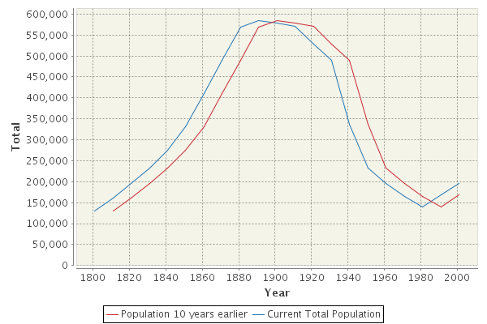
Infant mortality rate
(deaths per thousand live births)
Mortality rate

(Actual deaths as % of expected number compared to national deaths for each time period
The UK rate is broadly 100% and it is the difference from that which is significant for the area comparison. Age and gender have already been taken into account)

Death from specific diseases  Per 100,000 people | 2011
 |  | Early death from heart disease or stroke | Early death from cancer | death attributed to smoking | obesity  %
 | Tower Hamlets | 113 | 141 | 306 | 19.4 %
 | London | 75 | 108 | 207 | 21%
 | England | 70 | 112 | 216 | 24%
LSOA= Local small output area

Poverty in London 2000- 2011 http://sticerd.lse.ac.uk/dps/case/spcc/rr03.pdf

Activity
- For each graph make a prediction of where the line will be for 2010 and 2017 for Tower Hamlets and give reasons for your predictions.

- What can these graphs and maps tell us about Tower Hamlets as a changing place?

- Is life in Tower Hamlets getting better? What other data and indicators would help you to answer this question?

