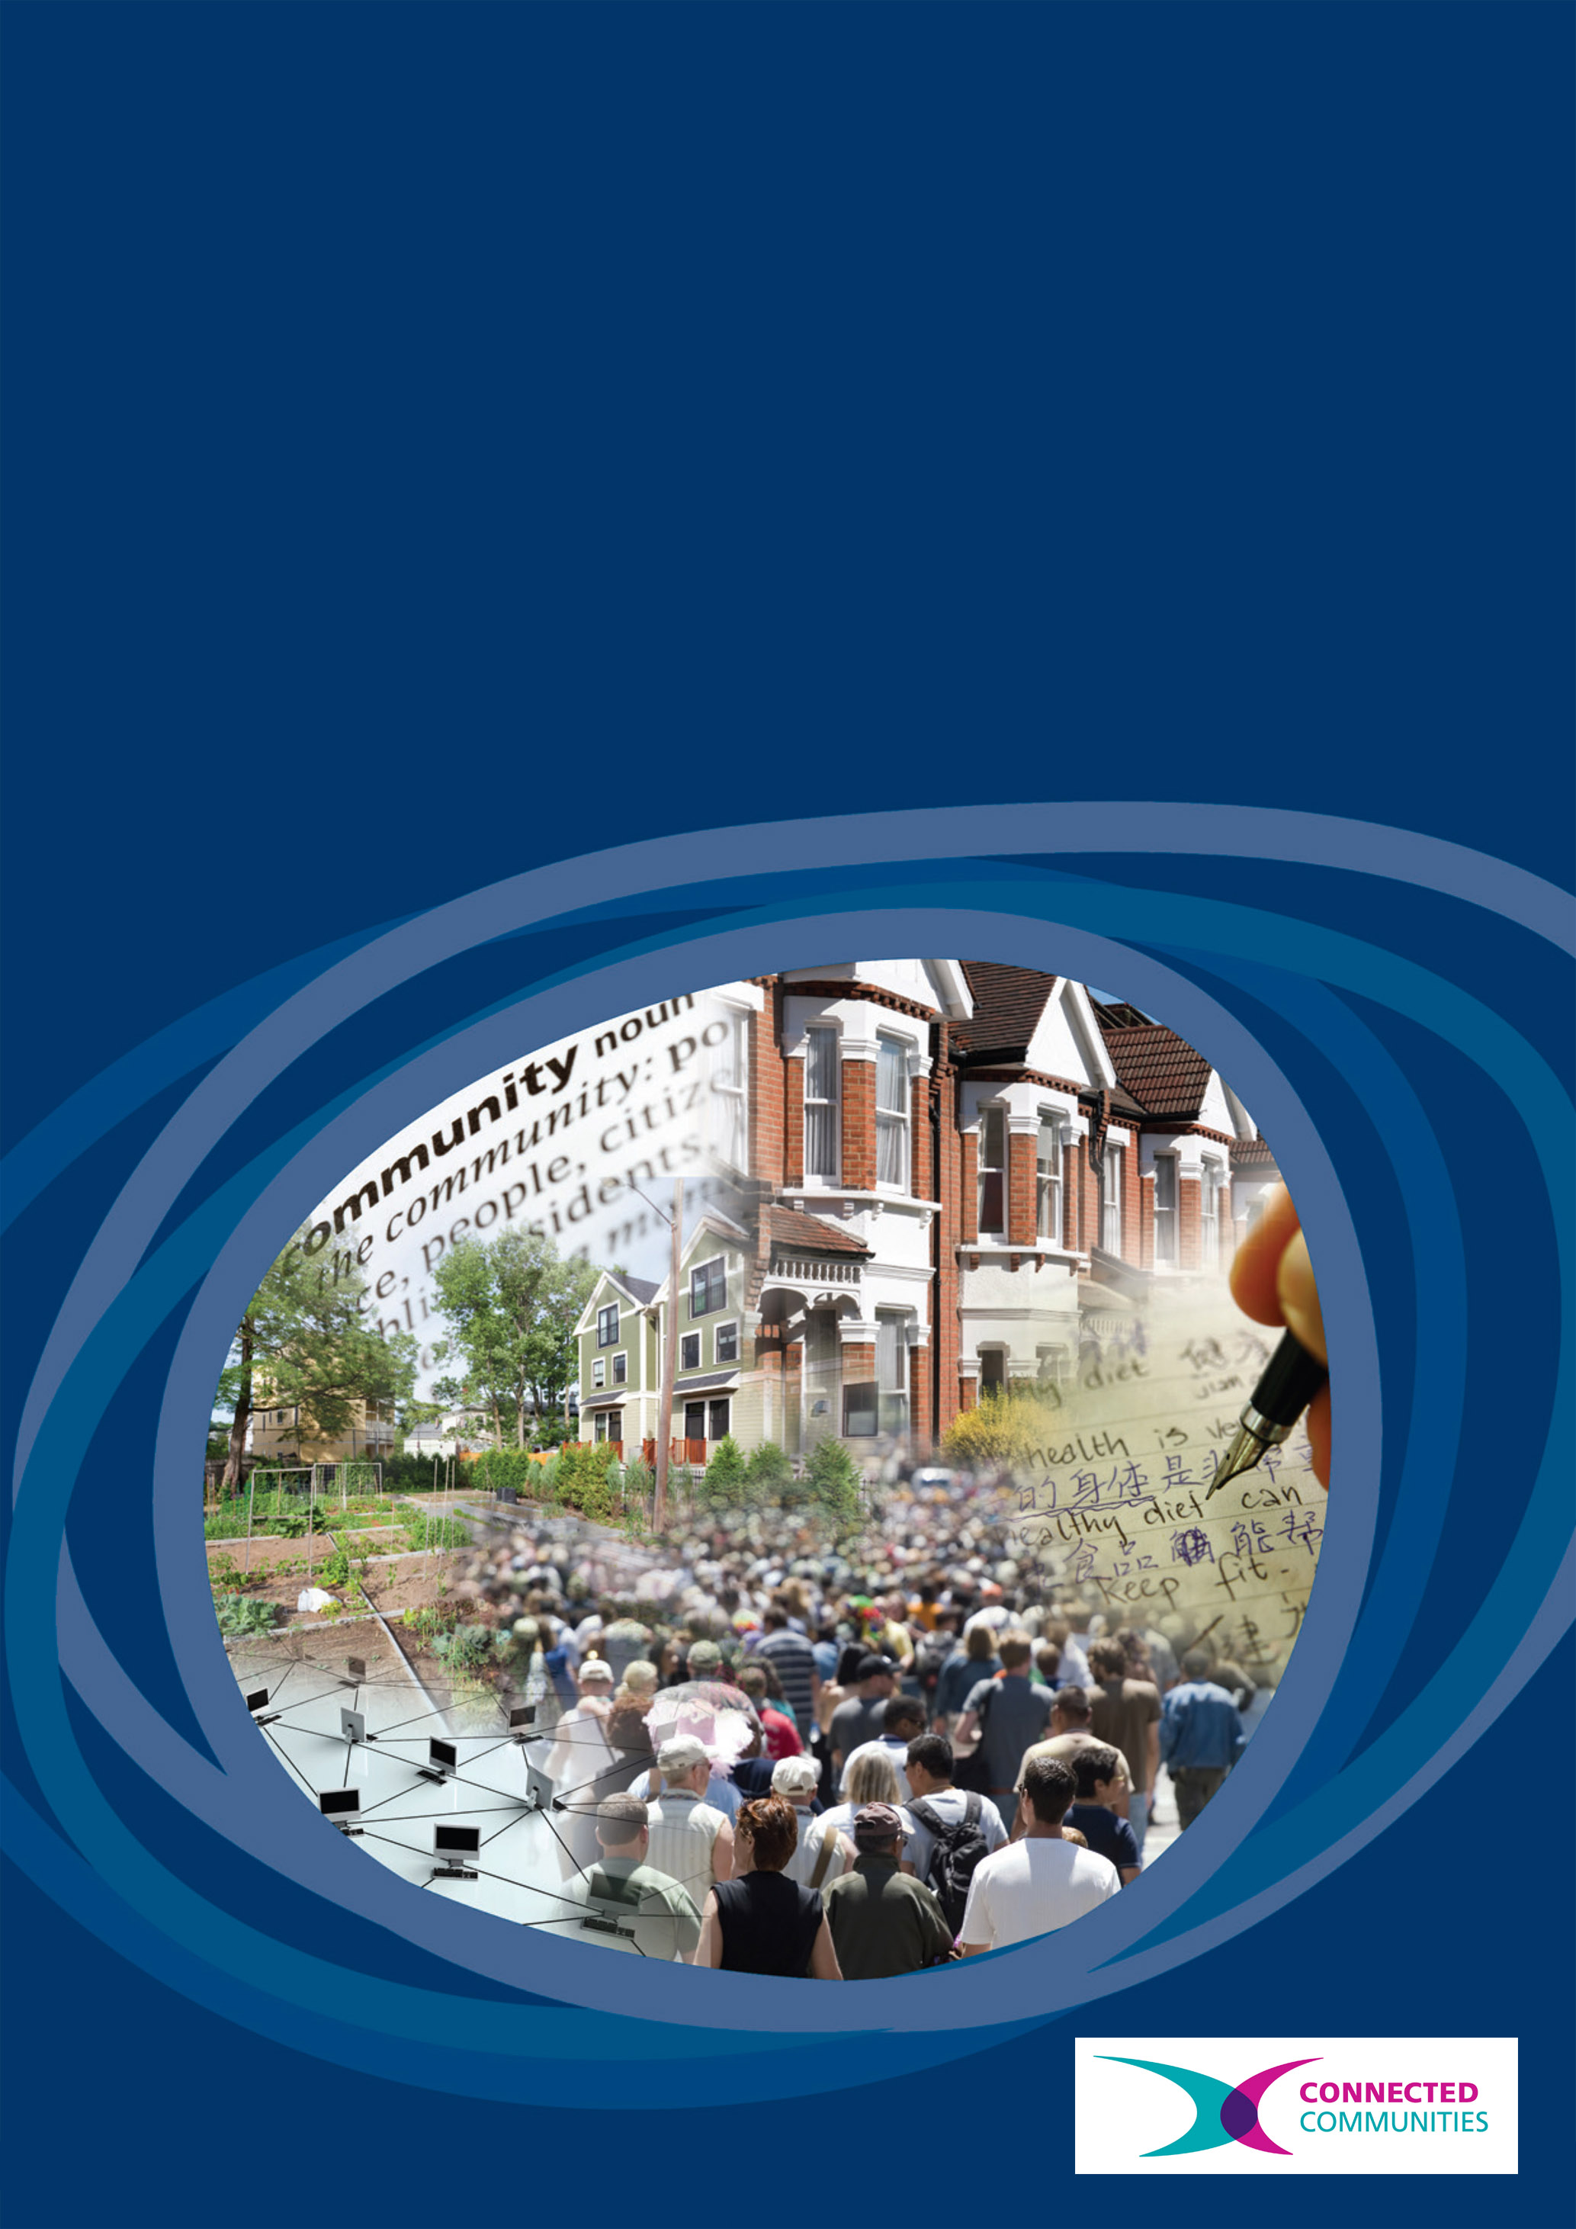
Connected Communities
Connected Communities: Diaspora and Transnationality
Alison Blunt, Jayani Bonnerjee, Cathy McIlwaine, Clifford Pereira
Connected Communities: Diaspora and Transnationality
Alison Blunt, Jayani Bonnerjee, Cathy McIlwaine, Cliff Pereira
1. Executive Summary
This research review critically explores the idea of ‘connected communities’ in relation to diaspora and transnationality across the humanities and social sciences. It develops the idea of ‘connectivity’ within and across communities that are transnational and diasporic, focusing on four key areas: community histories; home, community and migration; cities, communities and connections; and faith communities and religious diasporas. As an integral part of the research review (see Bonnerjee et al., 2011, for the full report), four one-day workshops on these themes were held in partnership with The Royal Geographical Society (with Institute of British Geographers) and The Geffrye Museum of the Home. These workshops (two at the RGS-IBG, one at The Geffrye and one at The City Centre, QMUL) brought together more than 70 participants from across the academic, arts/cultural and community sectors and involved a range of presentations, workshop activities and discussions about future collaborative research priorities. The full report reviews key academic debates on community, diaspora and transnationality; highlights key projects across the academic, arts/cultural and community sectors in a series of boxes; includes workshop summaries and evaluations; and identifies key areas for future collaborative research.
2. Researchers and Project Partners
The project team consisted of Alison Blunt (PI, Geography, QMUL), Jayani Bonnerjee (PDRA, Geography, QMUL), Cathy McIlwaine (Co-I, Geography, QMUL) and Cliff Pereira (community engagement facilitator), working in partnership with the Royal Geographical Society (with Institute of British Geographers) and The Geffrye Museum of the Home, the latter via the new Centre for Studies of Home (a partnership between QMUL and the Geffrye). Key partners in both organizations were Dr Catherine Souch and Dr Stephanie Wyse (Research and Higher Education, RGS-IBG), Eleanor John (Head of Collections and Exhibitions, Geffrye) and Alison Lightbown (Head of Learning and Education, Geffrye). The four workshops were attended by a total of 71 participants from across the academic, arts/cultural and community sectors (see section 7.1 for a full list of participants).

3. Key words
Community, diaspora, transnationality, migration, community histories, cities, home, religion

Connected Communities: Diaspora and Transnationality

This research review investigates how ideas about community intersect with those of diaspora and transnationality. It frames the idea of ‘connected communities’ not just as a connection between ‘here’ and ‘there’ and within one diasporic/transnational community, but also in terms of connections between different communities. It locates the idea of ‘connected communities’ within a politics of scale, exploring connections within and between communities from local neighbourhoods to wider diasporas. The research review, together with four one-day workshops, is structured around four key themes: community histories; home, migration and community; cities, communities and connections; and faith communities and religious diasporas.

4.1 Community Histories
Whilst community histories have generally focused on the local scale, histories of diasporic and transnational communities have extended their reach far beyond the locale. Building on the research of Hamilton and Shopes (2008) this review discusses ways in which memory studies are different from an oral history approach. It includes details of research on diasporic and transnational communities that have used oral histories and memory studies (Rodger and Herbert, 2008; Trim, 2011). Building on the idea of connections, the report also includes details of community archive groups that have worked in collaboration across academic, arts and cultural, and community sectors, such as the ‘Connecting Histories’ project and the East Midlands Oral History Archives. The review outlines the complex process of archiving community histories for diasporic and transnational communities (Fouseki, 2010).
The workshop on this theme (RGS-IBG, 6 May 2011) explored resources, methods and strategies for collecting, documenting and disseminating community histories and included presentations on the ‘World in the East End’ project at the V&A Museum of Childhood (Teresa Hare Duke and Eithne Nightingale), the ‘Crossing Continents: Connecting Communities’ exhibition at the RGS-IBG (Vandana Patel), the Bangla Stories project (Claire Alexander, LSE), the Refugee Communities History Project (Jenny Harding, London Metropolitan University) and the work of the Swadhinata Trust (Ansar Ahmed Ullah). Workshop activities included handling selected objects and images from the collections of the RGS-IBG as a way of prompting debate about community histories and how such resources can provide key sites for future collaborative research on community, diaspora and transnationality.

4.2 Home, Migration and Community
The home has become a central focus of research on diaspora and transnationality, spanning home-making practices, domestic architecture, material culture and wider senses of belonging and dwelling in the world. Three key themes underpin work on home, migration and community. First, home as a place of dwelling can be a site of connection within and across communities, as shown by research on the house as a material connection between ‘here’ and ‘there’ (Levin and Fincher, 2010), domestic material space (Tolia-Kelly, 2004), and cultures of food and other home-making practices (Longhurst et al. 2010). Second, the relationships between home and memory are important in forging connections within and between different communities, as shown by the use of reminiscence work as a research technique to establish a sense of connection (Fortier, 2000). Third, both home and community evoke a sense of belonging. Ideas about belonging connect people and communities to place through a sense of attachment and the articulation of identity (Mee and Wright, 2009) and have been explored in relation to feeling at home and not at home in cities and across wider diasporas (Blunt and Bonnerjee, forthcoming, Blunt, 2005, Ho, 2006).
The workshop on this theme (The Geffrye Museum of the Home, 29 June 2011) focused on connections between different homes both ‘here’ and ‘there’; home as a site of connection and/or disconnection between different communities; the ways in which home might create a sense of belonging and/or exclusion; and the ways in which memories of home shape domestic practices and home spaces after migration. Presentations focused on home, food and identity for the Yoruba community in London (Julie Botticello, SOAS), the work of Hackney Museum in community engagement with young women (Cheryl Bowen and Sue McAlpine), and the ‘Documenting home’ and ‘Stories of the World’ projects at the Geffrye (Louisa Knight and Hannah Lake). Two workshop activities were led by the Geffrye and focused on identifying cross cultural influences in the period rooms, contrasting rooms from before and during the twentieth century; and a practical session of reminiscence work, during which participants discussed an object that represented home to them. A final workshop session involved mapping the home to draw out connections to different places, cultures and communities.

4.3 Cities, Communities and Connections
Moving beyond the private sphere, this section of the review focuses on public and urban spaces of encounter between communities. It addresses the ways in which different cities are connected through their diasporic and transnational communities, and how connections are made across different communities in the city. The review outlines how studies of connections across diasporic and transnational communities and city can create a non-hierarchical urban theory across the Global North and South (Mayaram, 2009; Robinson, 2006). It also focuses on research that has studied connections across translocal space (Brickell and Datta, 2011). The review further emphasises the idea of living together with difference in the city (Valentine, 2008), and the politics of cosmopolitan and/or multicultural spaces (Keith, 2005) to analyse the contexts of connections involving diasporic and transnational communities.

The workshop on this theme (The City Centre, QMUL, 14 September 2011) focused on different maps of the city as a way of thinking about proximity and distance, connection and disconnection, both within and between different communities. Presentations addressed different encounters for the Latin American community at the Elephant and Castle (Patria Roman-Velazquez, City University), migrant workers and low-paid employment in London (Cathy McIlwaine, QMUL), memory maps of migrants from Calcutta (Jayani Bonnerjee, QMUL) and the work of the London Transport Museum in mapping connections across different cities and communities through the Stories of the World: Journeys project (Michelle Brown). Sue Mayo (Magic Me) spoke about her intergenerational work with the Women’s Library and led two workshop sessions focusing on mapping London. Ali Campbell (QMUL) talked about ‘The Living Map’ project and led a workshop session that created a performance about routes through the city.

4.4 Faith Communities and Religious Diasporas
Emphasising the importance of faith and religion in the lives of diasporic and transnational communities, and bringing together an interest in public and private connections within and between communities, the final section of the research review focuses on faith communities and religious diasporas and how faith itself can be used to create connections. The first section of the review outlines how scared sites symbolise connections across different places, migratory trajectories and communities (Gale, 2008; Naylor and Ryan, 1998; Glick Schiller, 2011). Second, the review includes work on religious festivals and processions to develop an idea of connection through mobility (Coleman and Eade, 2004; Jacobsen, 2008; Knott, 2010). Third, the review analyses how faith and religion have been used in transnational and local politics as a way to create communities and connections (Hepner, 2003; Jamoul and Wills, 2008; Mandaville, 2001). Finally, the review outlines how shared scared spaces embody the idea of connections between communities and explores how interfaith work can create active connections between communities.

The workshop on this theme (RGS-IBG, 12 October 2011) explored the ways in which faith can open up points of connection across communities, places and generations by focusing on religious practices, buildings and communities. Four presentations focused on Muslim communities and identities (Imogen Wallace, QMUL, Nazneen Ahmed, Kent, Hengameh Emami, Sunderland, and Shiban Akhbar, Oxford Brookes), whilst two others focused on diasporic religious landscapes (the Jewish cemetery at Queen Mary, Caron Lipman, QMUL, and suburban religious landscapes in London and Vancouver, Claire Dwyer, UCL). One workshop session focused on the role of religion in community engagement projects run by the RGS-IBG, and included discussion about particular objects from the collections (Eugene Rae), the ways in which faith is embedded in community engagement projects (Vandana Patel) and the importance of sacred places as sites of diasporic and transnational connection in the ‘Walk the World’ project (Jenny Lunn). The second workshop session was led by Rachel Heilbron from Three Faiths Forum and included a range of practical activities around dealing with controversy and conflict resolution and the importance of education, engagement and action in interfaith projects.

5. Recommendations for future research
A number of key areas for future research have emerged through the research review and workshop discussions. In particular:
- To develop collaborative research across the academic, arts/cultural and community sectors, and the recognition that those working in each sector bring a range of skills and experience particularly in terms of methodological innovation, community engagement and dissemination strategies.
- To foster dialogue and knowledge exchange about innovative methodologies developed across each sector, particularly in terms of working with objects and displays in museums (eg RGS-IBG collections, and the period rooms and collections of The Geffrye Museum of the Home), performative and other artistic practices (eg the intergenerational work of Magic Me and the performance work involved in Ali Campbell’s Living Map project), and a wide range of participatory and pedagogic techniques (eg interfaith workshops organized by Three Faiths Forum).
- To develop research on different spaces and scales of connection for transnational and diasporic communities, in particular building on projects that have focused on particular places (eg ‘The World in the East End,’ V&A Museum of Childhood, The Swadhinata Trust’s project on Bengalis in the East End, and the work of Eastside Community Heritage) and on connections over transnational and diasporic scales (eg ‘Crossing Continents: Connecting Communities, RGS-IBG; Stories of the World: Home, Geffrye; Stories of the World: Journeys, London Transport Museum).
- To build on the links established between workshop participants to develop collaborative community engagement projects about diasporic and transnational connections across the academic, arts/cultural and community sectors.
- To develop new collaborative research grant and/or CDA applications under the Connected Communities programme to examine:

1) Mapping connections across time and space: exploring community histories across generations among migrant groups in London;
2) Connecting faith across space in the city: the role of the arts and culture in promoting inter-faith dialogue and action;
3) Home, migration and community: home as a site of inclusion and exclusion for migrant communities and the connections between home, work and the wider city.
- To build on the partnership between QMUL, the RGS-IBG and The Geffrye Museum of the Home via the QMUL-led AHRC knowledge exchange hub, Creativeworks London, in which both other organizations are named partners.

6. Outputs
A 20,000 word report, including a full research review on ‘Connected communities: diaspora and transnationality,’ summaries of the four workshops, and boxes highlighting key projects discussed in the workshops, has been written by the project team and distributed (together with this short report) to all workshop participants:
J. Bonnerjee, A. Blunt, C. McIlwaine and C. Pereira (2011) ‘Connected communities: diaspora and transnationality.’
Printed copies are available from Dr Jayani Bonnerjee, School of Geography, Queen Mary, University of London, E1 4NS (j.bonnerjee@qmul.ac.uk). The report can also be downloaded from www.geog.qmul.ac.uk.

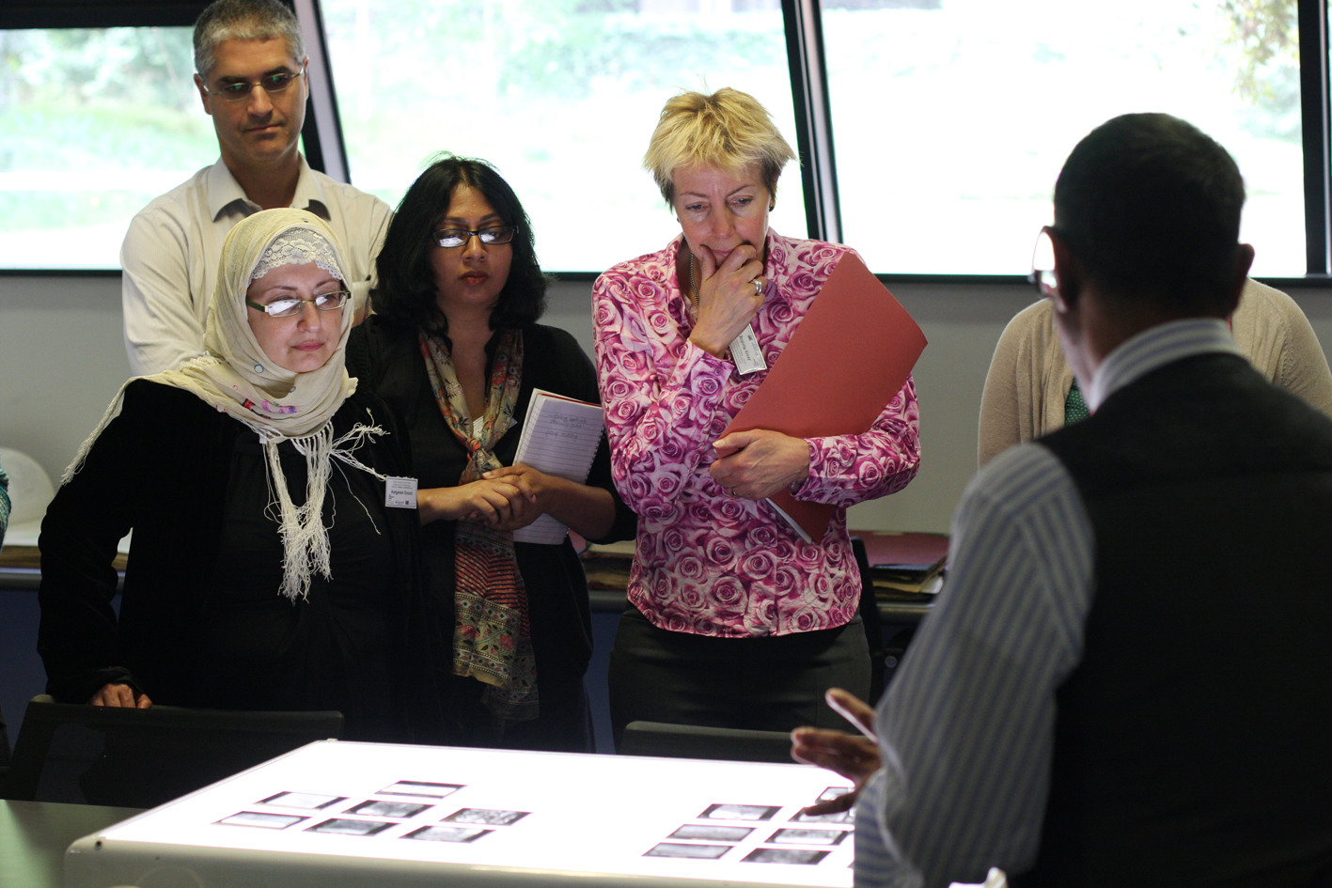
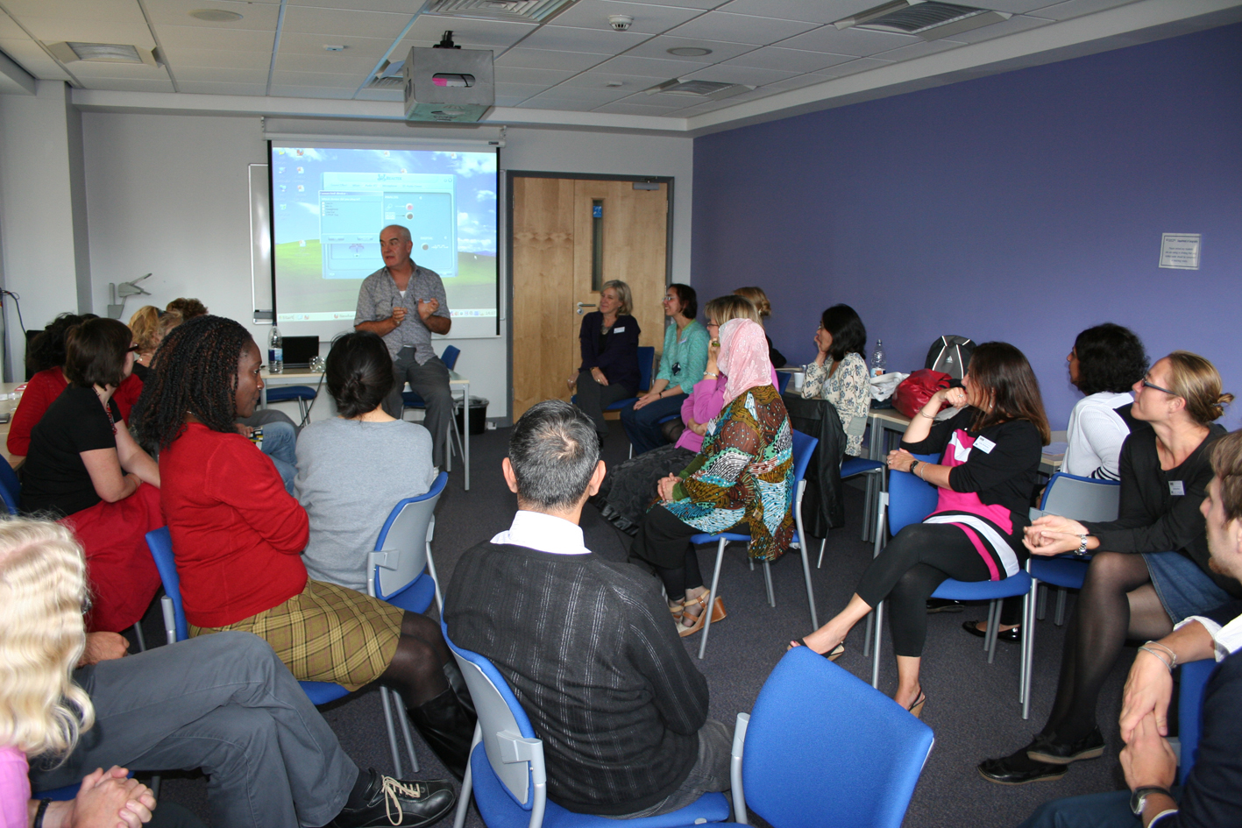
Workshop activities at workshop 1 (RGS-IBG) and 3 (City Centre, QMUL).

7. Appendices
7.1 Workshop Participants
Lydia Agard | Museum of London | Michael Keith | COMPAS, University of Oxford
Nazneen Ahmed | University of Kent | Anne Kershen | QMUL
Shiban Akbhar | Oxford Brookes University | Meena Khatwa | Birkbeck and Bombay Mix
Claire Alexander | LSE | Louisa Knight | The Geffrye Museum
Joy Annika | Science Museum | Cathie Krull | Institute for the Study of the Americas, Univ. of London
Camille Aznar | QMUL | Shompa Lahiri | QMUL
Richard Baxter | QMUL | Hannah Lake | The Geffrye Museum
ura Bedford | The Geffrye Museum | Susan Langford | Magic Me
Julie Begum | The Geffrye Museum | Mathew Larkinson | The Geffrye Museum
Alison Blunt | QMUL | Alison Lightbown | The Geffrye Museum
Jayani Bonnerjee | QMUL | Caron Lipman | QMUL
Julie Botticello | SOAS | Jenny Lunn | RGS-IBG
Cheryl Bowen | Hackney Museum | Sarah May | English Heritage
Katherine Brickell | Royal Holloway, University of London | Sue Mayo | Magic Me
Michelle Brown | London Transport Museum | Sue McAlpine | Hackney Museum
Cathrine Brun | NTNU, Norway | Cathy McIlwaine | QMUL
Sofia Buchuck | Independent researcher | Michael Murray | Heritage Lottery Fund
Kathy Burrell | De Montfort University | Eithne Nightingale | V&A
Alistair Campbell | QMUL | Vandana Patel | RGS-IBG
Selma Carvalho | Author, Into the Diaspora Wilderness | Ben Pearce | Economic Development and Olympic Legacy Team
Amanda Claremont | Women’s Design Service | Cliff Pereira | Community engagement facilitator
Kavita Datta | QMUL | Alisa Petroff | Autonomous University of Barcelona / QMUL
Robyn Dowling | Macquarie University, Australia | Eugene Rae | RGS-IBG
Claire Dwyer | UCL | Alejandra Serpente | Institute for the Study of the Americas, Univ. of London
Isabel Dyck | QMUL | Hae Ran Shin | University College London
Hengameh Ashraf Emami | Sunderland University | Catherine Souch | RGS-IBG
Sarah Evans | University of the West of England | Gil Toffell | QMUL
Richard Gale | Cardiff University | Dimitrios Tourontsis | Hackney Museum
Judith Garfield | Eastside Community Heritage | Jo Turner | Three Faiths Forum
Ben Gidley | COMPAS University of Oxford | Patria Roman-Velasquez | City University
Alex Goddard | The Geffrye Museum | Ansar Ahmed Ullah | Swadhinata Trust
Jenny Harding | London Metropolitan University | Libia Villazana | Institute for the Study of the Americas, Univ. of London
Teresa Hare Duke | V&A Museum of Childhood | Imogen Wallace | QMUL
Madeleine Hatfield | RGS-IBG | Jane Wills | QMUL
Rachel Heilbron | Three Faiths Forum | Stephanie Wyse | RGS-IBG
Eleanor John | The Geffrye Museum

References
Blunt, A., Domicile and Diaspora: Anglo-Indian women and the spatial politics of home, Oxford: Blackwell, 2005
Blunt., A. and Bonnerjee ‘Home, city and diaspora: Anglo-Indian and Chinese attachments to Calcutta.’ Global Networks, (forthcoming)
Bonnerjee, J., Blunt, A., McIlwaine, C. and Pereira, C. (2011) ‘Connected communities: diaspora and transnationality.’ Full report available from j.bonnerjee@qmul.ac.uk.
Brickell, K. and Datta, A. Translocal geographies: spaces, places, connections, Farnham: Ashgate Publishing, 2011
Coleman, S. and Eade, J. Reframing pilgrimage: cultures in motion, London: Routledge, 2004
Fortier, A.M. Migrant belongings: memory, space, identity, Oxford: Berg, 2000
Fouseki, K. ‘Community voices, curatorial choices’: community consultation for the 1807 exhibitions, Museum and Society 2010, 8(3): 180-192
Gale, R. Representing the city: mosques and the planning process in Birmingham. Journal of Ethnic and Migration Studies 2005, 31: 1161-79
Glick Schiller, N.; Darieva, T. and Gruner-Domic, S. Defining cosmopolitan sociability in a transnational age: an introduction. Ethnic and Racial Studies 2011, 34(3): 399-418
Hamilton, P. and Shopes, L. (ed.) Oral histories and public memories, Philadelphia, PA: Temple University Press, 2008
Hepner, T.R. Religion, nationalism and transnational civil society in the Eritrean diaspora, Identities, 2003, vol. 10 (3): 269-293,
Ho, E. ‘Negotiating belonging and perceptions of citizenship in a transnational world: Singapore, a cosmopolis?’. Social and Cultural Geography 2006, 7: 385-401
Jacobsen, K. South Asian religions on display: religious processions in South Asia and in the diaspora, Abingdon: Routledge, 2008
Jamoul, L. and Wills, J. Faith in politics, Urban Studies 2008, 45(10):2035-2056
Keith, M. After the Cosmopolitan? Multicultural cities and the future of racism, London, New York: Routledge, 2005
Knott, K. ‘Geography, space and the sacred’ in J.R. Hinnels (ed) The Routledge companion to the study of religion, Abingdon and New York: Routledge. Pp. 476-491, 2010
Levin, I. and Fincher, R. Tangible transnational links in the houses of Italian migrants in Melbourne, Global Networks 2010, 10(3): 401-423
Longhurst, R.; Johnston, L. and Ho, E. ‘A visceral approach: cooking ‘at home’ with migrant women at Hamilton, New Zealand’, Transactions, 34: 333-345, 2009
Mandaville, P.G. Transnational Muslim politics: reimagining the umma, London: Routledge, 2001
Mayaram, S. (ed.) The other global city. London: Routledge, 2009
Mee, K. and Wright, S. Guest editorial ‘Geographies of belonging’. Environment and Planning A, 2009, 41: 772-779
Naylor, S. and J. Ryan ‘Mosques, temples and gurdwaras: new sites of religion in twentieth century Britain. In David Glibert et al. (eds) Geographies of British Identity: space and society in the twentieth century, Malden, MA: Blackwell Publishing, pp. 168-184, 2003
Robinson, J. Ordinary Cities: between modernity and development, London, New York: Routledge, 2008
Rodger, R. and Herbert, J. (ed) Testimonies of the city: identity, community and change in a contemporary urban world, Aldershot: Ashgate Publishing Ltd., 2008
Tolia-Kelly, D. ‘Locating processes of identification: studying the precipitates of re-memory through artefacts in the British Asian home’, Transactions of the Institute of British Geographers, 2004, 29:314-329
Trim, D.J.B. (ed) The Huguenots: history and memory in transnational context, Brill Academic Publication. 2011
Valentine, G. ‘Living with difference: reflections on geographies of encounter’, Progress in Human Geography, 2008, 32(3): 323-337


The Connected Communities

Connected Communities is a cross-Council Programme being led by the AHRC in partnership with the EPSRC, ESRC, MRC and NERC and a range of external partners. The current vision for the Programme is:

“to mobilise the potential for increasingly inter-connected, culturally diverse, communities to enhance participation, prosperity, sustainability, health & well-being by better connecting research, stakeholders and communities.”

Further details about the Programme can be found on the AHRC’s Connected Communities web pages at:

www.ahrc.ac.uk/FundingOpportunities/Pages/connectedcommunities.aspx

